Our business website: https://www.vanislewaterproofing.ca/

This is where the information that will be pulled into the site will live. It could be updated on the sheet and automatically synced to the app, OR we can edit it directly in the app: https://docs.google.com/spreadsheets/d/1EKxNsSK7GyZ3OYhTupU9XLWnv9tgj79SoyFF-jE0Ck0/edit?usp=sharing

The tool has to have: Customer Name, Project Name, Address (synced from Quickbooks or BuilderTrend on a daily basis as we add jobs often), Date & Time Stamps for new entries, and a photo capture for Inventory & Materials. Cost tracking. Easy exports or shareable to CFO.

Nice to have: It would be cool if the team member could earn points when they complete all task items. I’d like to reward them when they fill out all sections. Team Member SIGN OFF section to confirm they have done all required actions. The points will flow through to another dashboard that we’d like to be created after this one. These two platforms should collect points and consolidate them.

The tool will be called Waterproofing+ Warehouse Wizard

Inventory - Products to perform our services

Goal: Reduce inventory shrinkage. Ensure we are always stocked with the right amount of inventory and not overspending on unnecessary new orders.

Solution - Track inventory to better understand project costs. Ensure that we always have the right products to perform each service on-time and on-budget.

We need a system to track inventory as it comes into the warehouse, when it leaves, which site it goes to, and how much is used at each site. This will help us track inventory so we know the real cost of jobs

Our current process is clunky:
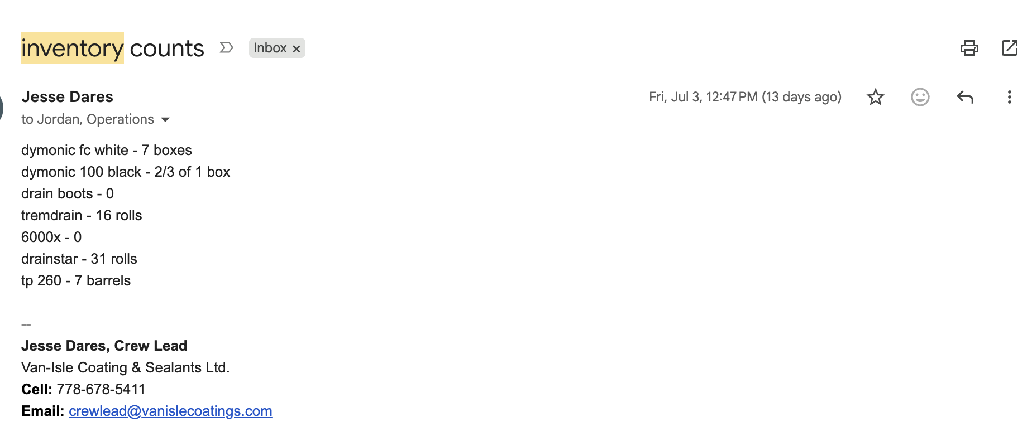
- Crew lead tracks what inventory is in the warehouse at the beginning of every month via email
  - Issue: clunky and doesn’t cover a specific set of quantities for each product type
  - Issue: Units don’t match what the team uses ex ⅔ of 1 box should equal an exact # of pins

- Team member completes a work order in BuilderTrend. Under NOTES they put quantities DELIVERED and/or quantities USED
  - Issue #1 - This doesn’t say how much was at the warehouse before they go to the site
  - Issue #2 - This is highly manual for the admin team, as they need to go in every month and manually log the quantities
  - Issue #3 - no set unit per item (see product roamap). We need to set the guidelines for the quantities the crew can use
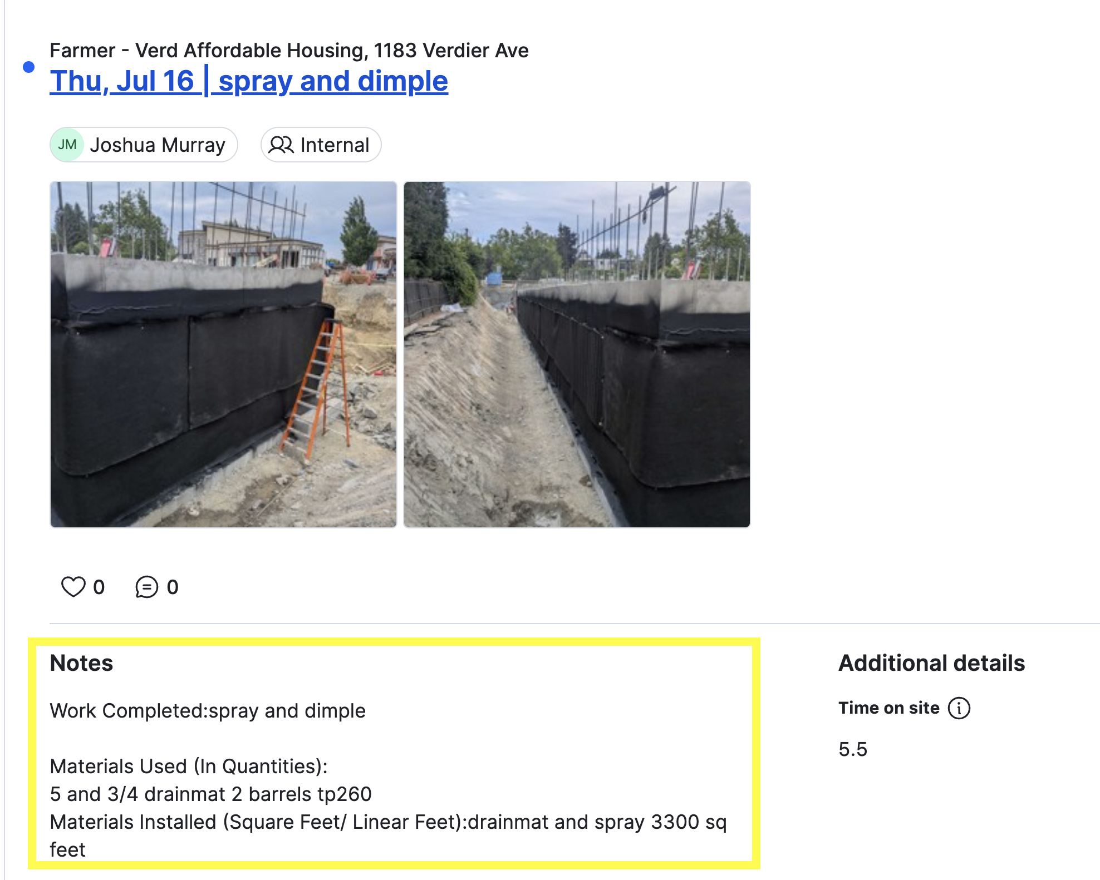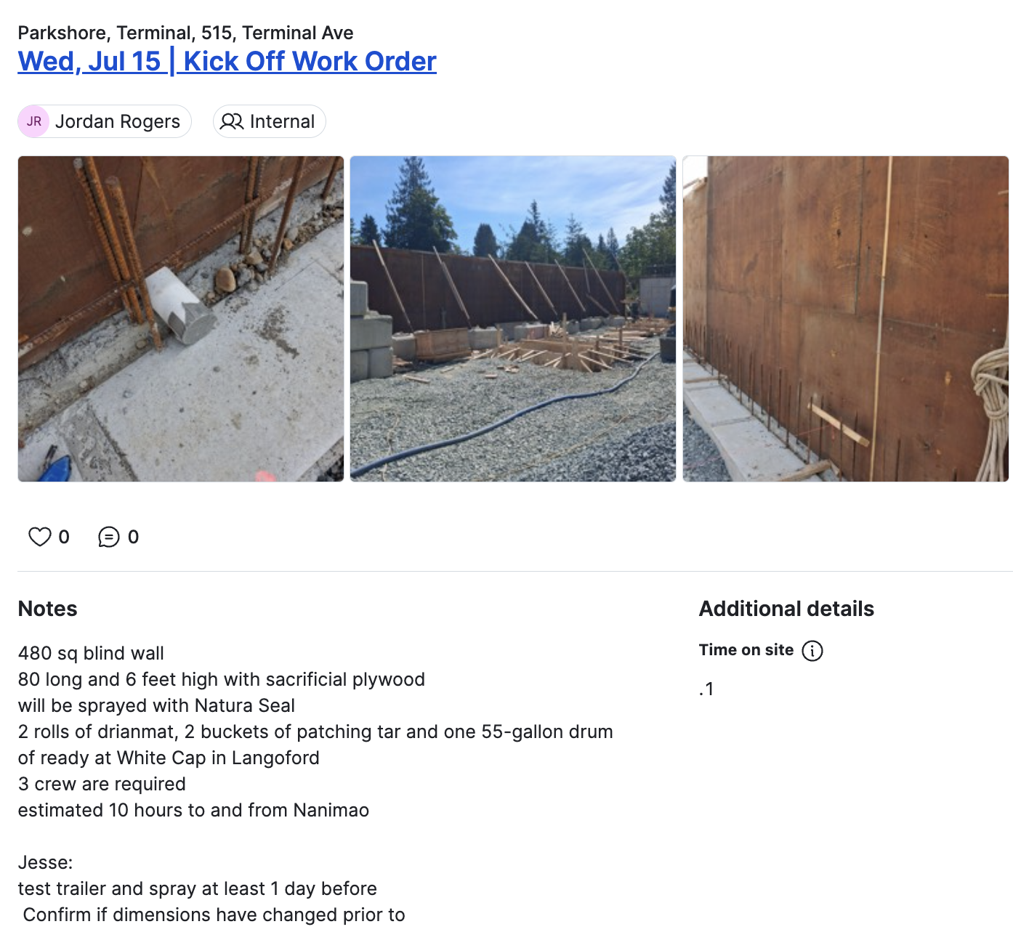

- Admin goes into the work order at the end of each month and pulls the quantities into this spreadsheet https://docs.google.com/spreadsheets/d/1R7dN_CVQS0qzx8rP1aPHt0ND2qnwHCnXAgd1l2PUHVw/edit?usp=sharing
  - This system takes a lot of time to input the info and for the CFO to export for cost analysis
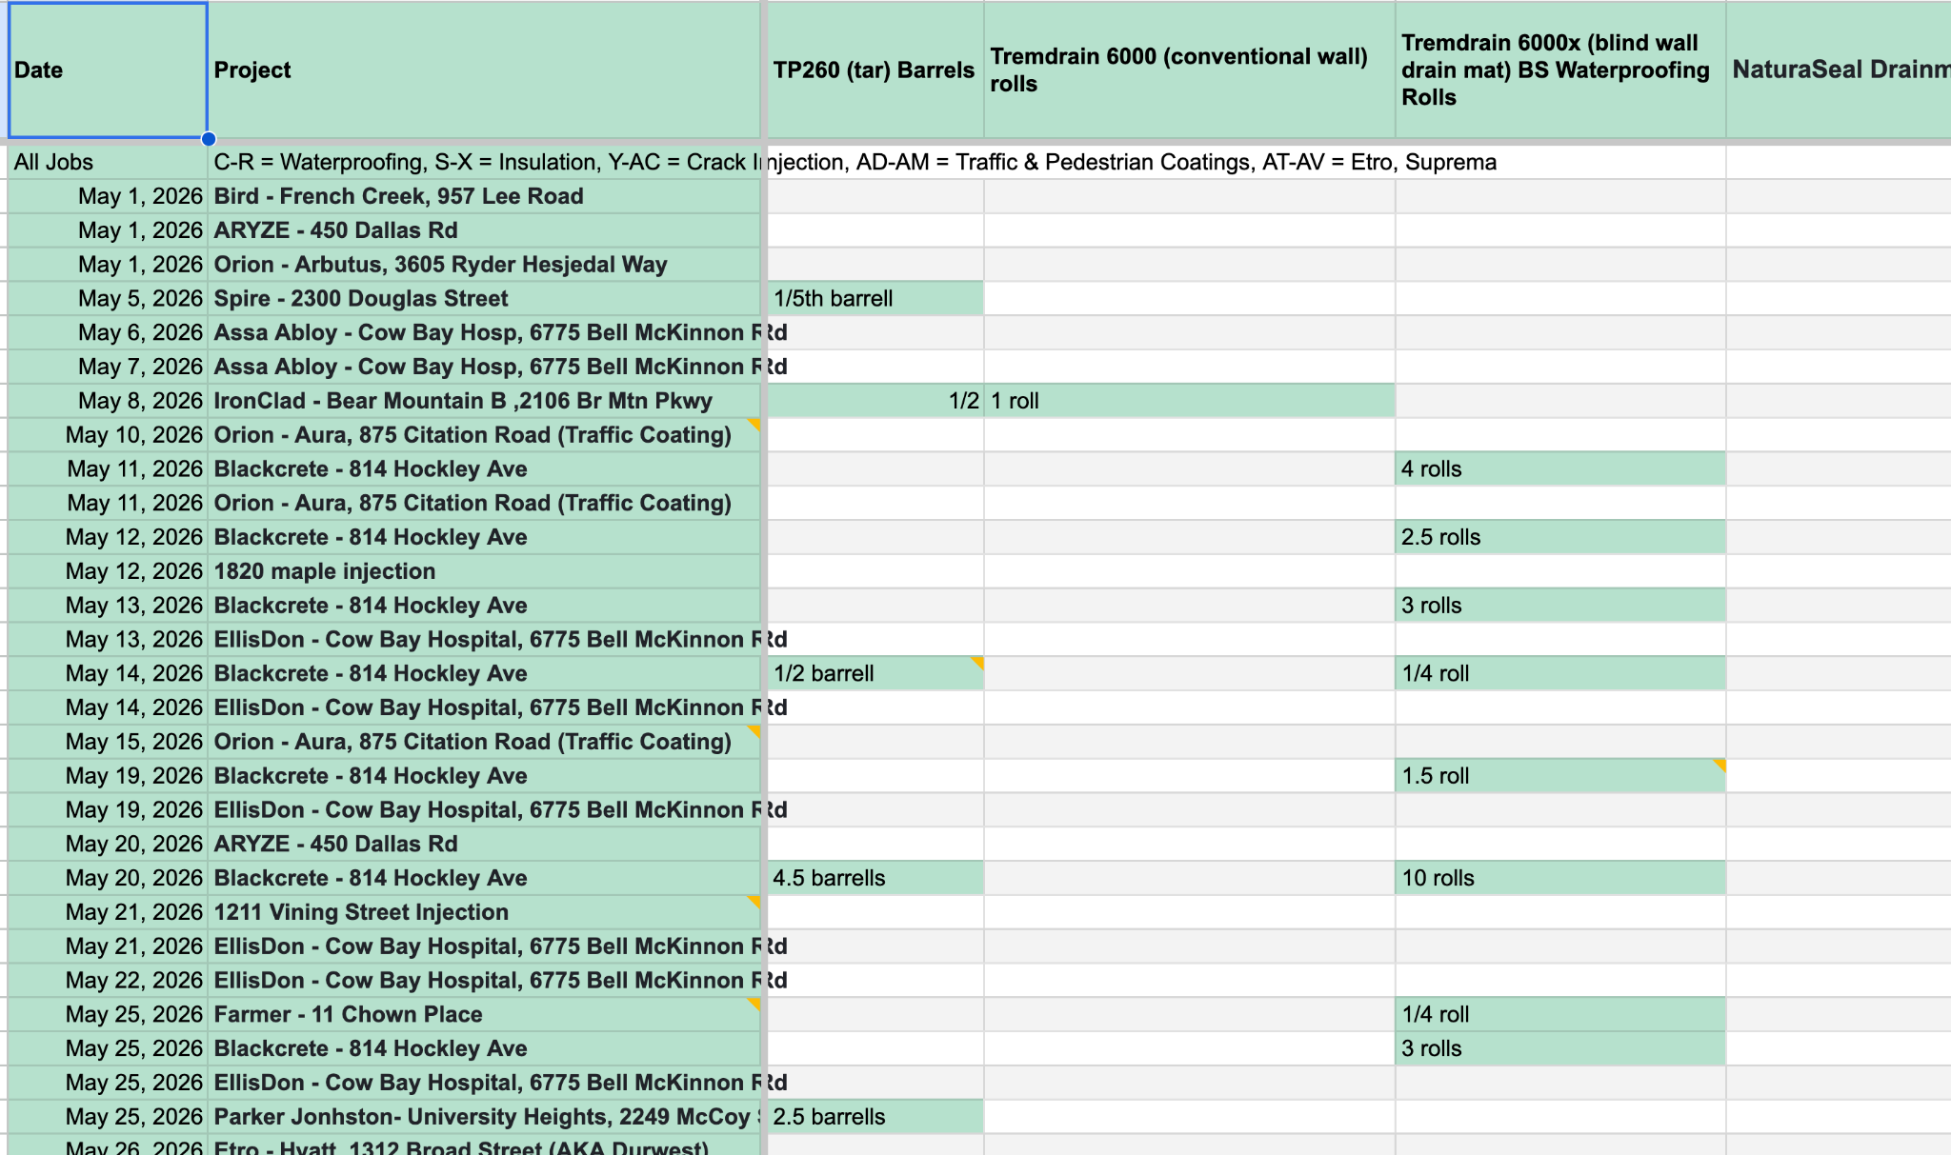
- Our CFO uses these numbers to track inventory to job costs per project

What’s missing: Tracking the inventory easily at the warehouse before it leaves, manually tracking what’s delivered and what’s used on a daily basis on one place. If there’s a way to use Zapier to automatically pull the inventory quantities from the work log this would be great.

Materials - Tools, Machines, Job Supplies, Safety Equipment

Goal - Ensure the team is prepared with the best tools for the job, and they are in working order + returned in the same condition for the next user.

Solution - The crew never has to get to a site and a tool is forgotten, broken, or the battery is dead.

Our current process is clunky:

- Materials in the warehouse are organized by service
  - A photo should be uploaded showing what the ideal display is so the crew knows to take and bring back things and place them tidily
- The crew member takes a material (Drill, Tool, Screw) from that area and logs how much they took
  - If they sign out a tool, they must say what tool it was
- The crew member needs to check if the tool works before leaving the warehouse
  - Ex. is it charged? Operational?
- The crew member needs to track which site it goes to
- The crew member needs to check the tool back in

A good example here is a ladder. They get left at job sites all the time, so the person who took them out needs to be responsible for getting them back

Materials Costs
- We need to be able to add the price of the inventory
  - Ex. Drain Mat
- We need to be able to add the price of materials
  - Example: PPE, ladder, hammer, etc
- It would be cool if we could track how costs change over time to see what vendors are charging us more
  - A reminder to update/check product costs for the admin

Truck Logs
Goal: Keep the crews in working order and have all the right materials loaded for the job, reducing the need to run around to pick up items they forgot to load or that were not in working order.

Solution: The crew never has to worry that they aren’t fully prepared for a job again.

This is not as important as inventory and materials tracking
- Daily Morning Tasks
- Daily Evening Tasks
- Weekly Tasks
- Monthly Tasks
  - Check Oil
- Annual Tasks
  - Ex. Renew insurance

The goal with the site is to have everything in a dashboard and easy to update and pull data from.

